Name
Date
Period

Elements, Compounds, Mixtures and Atoms study sheet

- What is the smallest part of elements that still retains all the properties of that element? Atom

- Explain how to read the “code” for writing elements symbols:
Every element symbol must contain only one capital letter and can contain up to two lowercase letter. When reading compounds you count the number of capital letters to tell how many elements are in the compound.

- Where can you find a list of all the elements in the known universe?
Periodic table of elements
- An atom is made up of three parts, what are those three parts?
Protons (+), Neutrons (0), and Electrons (-)

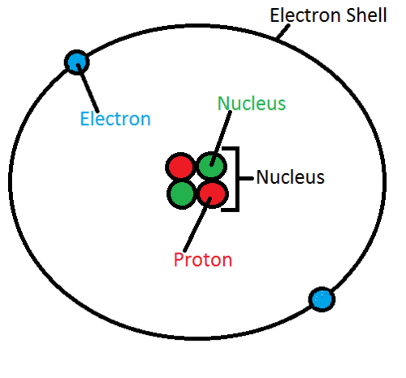
- Draw a model of a helium atom and label the protons, neutrons, and electrons and include their charge:

- What is a molecule?
The smallest part of a substance that still contains all the properties of that substance Example: H2O is a molecule and so is O2

- What is an element?
Elements are the simplest substances that cannot be broken down into anything else. Elements combine to make compounds, there are over 100 known elements

- What is a compound?
Two or more elements combined in a specific ratio Example NaCl, H2O, CO2 Compounds are brand new substances with different properties from their parent elements. Cannot be easily separated

- What is a mixture?
When you put substances together but they can be easily separated, example cereal with raisins, chex mix, salad, also includes solutions like salt water and lemonade.
- What is a solution?
A special types of mixture where one substance is dissolved in a liquid but the two substances still retain their individual properties. These can be easily separated, examples: Salt water can be separated by boiling the water.

- Are compounds and molecules the same? Explain:
No they are different both are specific ratios, meaning they always occur in exact amounts like H2O or O2, but you can have a molecule of an element like O2 and a molecule of a compound like H2O
- What are the common names of the following compounds:
  - H2O Water
  - CO2 Carbon dioxide
  - NaCl salt

- Look at the following list and label them as compounds, elements or mixtures
Name | Compound,element,mix | Is it a solution
Salt water | Mixture | Yes
C6H12o6 | Compound | No
Lemonade | Mixture | Yes
Gold | Element | No
Air | Mixture | No
Aluminum | Element | No
H2O | Compound | No

- in your experiment you added salt to hot water, what was the purpose of heating the water? The heat made to molecules in the water move faster so it was able to take more salt. The heat also made the salt dissolve more quickly.

- What two words will a properly written hypothesis have in it?
IF and THEN

- When we dissolved the salt in the water for our experiment did the salt loose any of its properties?
No when you create a mixture or solution the individual substances do not change. The water is still water and the salt is still salt, they are just in the same cup now.
- What is the quickest way to separate our salt from the water in the classroom?
If you boil a solution you will separate the parts quickly. Boiling salt water will leave you with just salt, and boiling kool-aid will leave you with just sugar and flavoring mix.

- Explain the difference between manipulated and responding variable:
Manipulated variable is the part of an experiment that you change on purpose, it is the “IF” part of the hypothesis. The Responding Variable is the part of the experiment that changes because of what you “Manipulated” it is the “THEN” part of the hypothesis

