Sound Notes

- Sound is a form of energy produced and transmitted by vibrating matter.
- Sound waves are compression (longitudinal) waves.
- When compression (longitudinal) waves move through matter (solid, liquid, or a gas), the molecules of the matter move backward and forward in the direction in which the wave is traveling. As sound waves travel, molecules are pressed together in some parts (compression) and in some parts are spread out (rarefaction). A child’s toy in the form of a coil is a good tool to demonstrate a compression (longitudinal) wave.
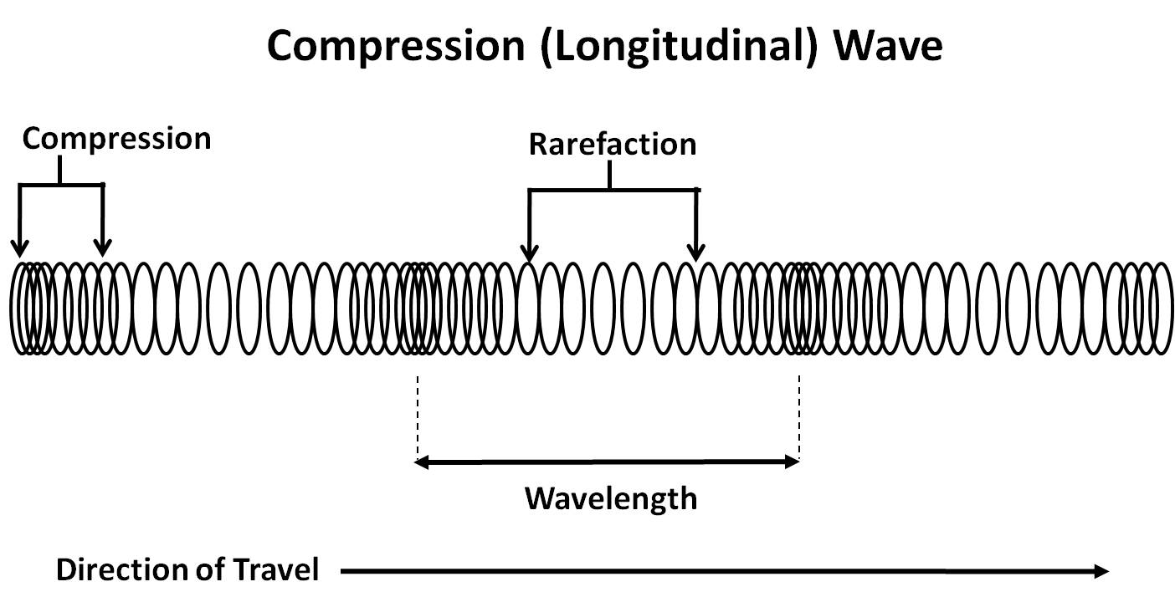
- The frequency of sound is the number of wavelengths in a given unit of time.
- The wavelength of sound is the distance between two compressions or between two rarefactions. The wavelength can be measured from any point on a wave as long as it is measured to the same point on the next wave.
- When we talk, sound waves travel in air. Sound also travels in liquids and solids. Sound waves must have a medium through which to travel. In a vacuum sound cannot travel because there is no matter for it to move through.
- Pitch is determined by the frequency of a vibrating object. Objects vibrating faster have a higher pitch than objects vibrating slower. A change in frequency of sound waves causes an audible sensation—a difference in pitch.
- Amplitude is the amount of energy in a compression (longitudinal) wave and is related to intensity and volume. For example, when a loud sound is heard, it is because many molecules have been vibrated with much force. A soft sound is made with fewer molecules being vibrated with less force.
- Sound travels more quickly through solids than through liquids and gases because the molecules of a solid are closer together. Sound travels the slowest through gases because the molecules of a gas are farthest apart.
- Some animals make and hear ranges of sound vibrations different from those that humans can make and hear.
- Musical instruments vibrate to produce sound. There are many different types of musical instruments and each instrument causes the vibrations in different ways. The most widely accepted way to classify musical instruments is to classify them by the way in which the sound is produced by the instrument. The four basic classifications are percussion instruments (e.g., drums, cymbals), stringed instruments (e.g., violin, piano, guitar), wind instruments (e.g., flute, clarinet, trumpet, trombone), and electronic instruments (e.g., electronic organ, electric guitar).

Label all the parts of the wave with the following words: Wavelength, compression wave, compression, rarefaction

