Rock Cycle Test Review Sheet

1. Complete the Chart
Type of Rock | How it forms | Example
Igneous | Cooling and hardening of magma or lava | Obsidian and Granite
Metamorphic | Heat and pressure | Slate and Gneiss
Sedimentary | Weathering, Erosion, Deposition, compaction, cementation | Sandstone, limestone

2. Granite is an igneous rock and it changes into Gneiss which is metamorphic, what process caused this change?
Heat and pressure
3. What is the difference between lava and magma? And what type of rock does each one form? Lava is on the surface of the earth and magma is underground both are considered molten material until they cool and harden then they form igneous rock

Use the chart to answer the next three questions: 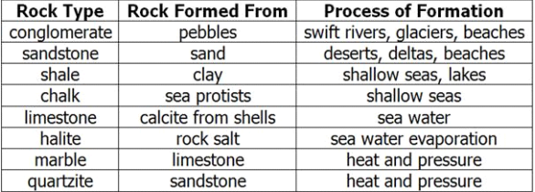

4. What rock is made from sand?
Sandstone
5. Which rocks use the water cycle to help them form?
Conglomerate, Sandstone, Shale, Chalk, Limestone, Halite
6. What is chalk made out of?
Sea Protists
7. In which type of rock do we find fossils? Sedimentary Rocks

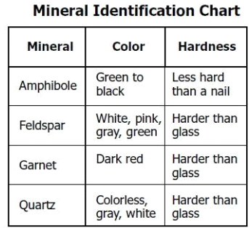
8. a student is looking at a mineral that is gray in color and harder then glass, what two minerals might they be looking at?
a. Quartz
b. Feldspar
9. A scientist is trying to identify a dark red mineral, what might it be?
Garnet

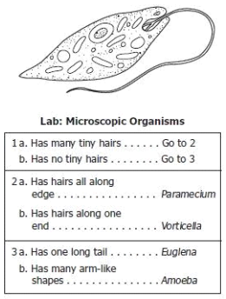
Use the chart to the right to answer the next two questions:

10. What is the organism pictured to the right
Euglena

11. Look at the picture to the right, what is it not?
Paramecium
Vorticella
Amoeba

