Notes Light test

•Transparent- see through little distortion; example glass

•Translucent – light passes through but some distortion hard to make out shapes; example- plastic bag, cloudy water

•Opaque – light does not pass through Example- brick wall

Reflection-light bouncing off of an object like a mirror, water, clothing,
-the color we see is the color that is reflected from the object
- white light is all of the visible spectrum combined
-black is something absorbing all of the colors of the visible spectrum
Refraction- bending of light like a prism bending light into its different colors shown in the diagram below or when you put a straw in water and it looks broken
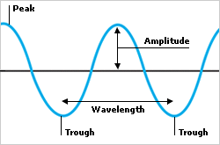
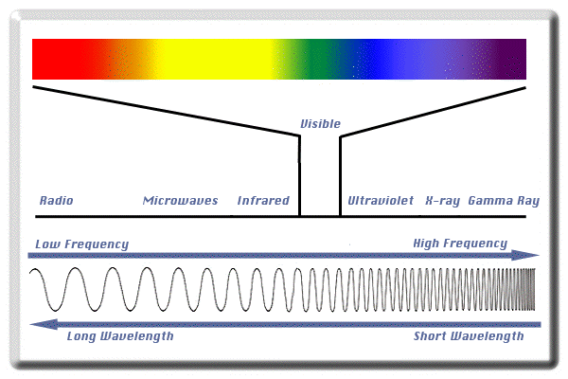
Red Orange Yellow Green Blue Indigo Violet

