Geology Test Review sheet

When looking at layers of rock describe how you can tell which rocks are the oldest in the layers?

The oldest rock layers are typically on bottom. This means the deeper the rock layer the older the rock.

When looking at fossils in layers of rock describe how you can tell which fossils are the oldest?

The oldest fossils are found in the lowest rock layers. If you have two fossils found in the same area but one is found deeper in the ground then it is typically older.

What is a fossil?

A fossil is remains or evidence of something that was once living. Dinosaur bones are fossils as are seashells; impressions left by plants in mud that turns to stone over the years are also fossils.

A student finds seashells on top of a mountain in North Carolina. Explain how this could happen:

This area must have once been under the ocean. Many years ago this area would have been covered by water and organisms lived in that water. Then uplift lifted the land and now it is on a mountain top instead of underwater

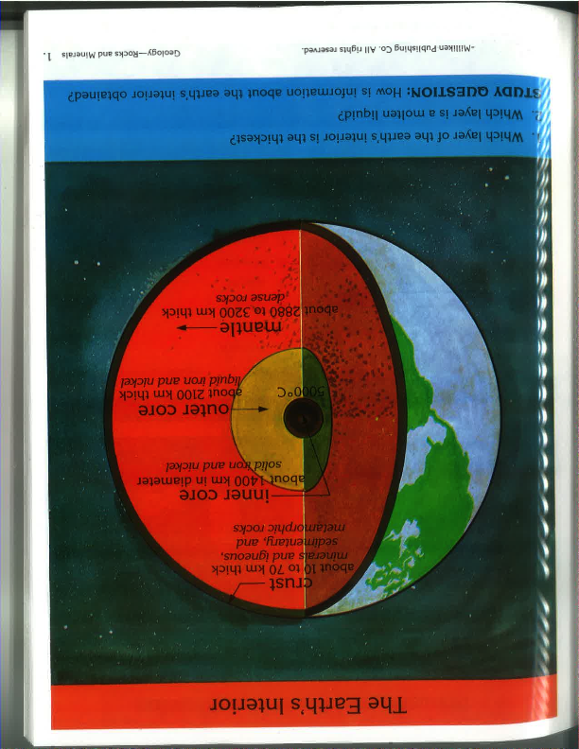In the space below draw a diagram of the layers of the earth label them and make sure your diagram is proportional

List the layers of the earth in order of hottest to coldest:

Inner core, outer core, mantle, crust

List the layers of the earth in order of thinnest to thickest:

Crust, inner core, outer core, mantle

The theory of plate tectonics states Earths crust is broken up into pieces called plates. On what plate will you find North America?

**North American plate**

Name the two types of crust.

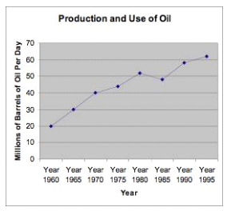**Oceanic (thin) and Continental (thick)**

Using the chart to the right make an inference about the amount of oil that has be produced over the years.

Oil production has increased over the years and oil production is likely to continue to increase in the years to come

In what year was the most oil used?

1995

In what year was the least oil used?

1960

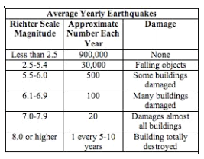Which magnitude of earthquake would be the most dangerous?

**8 or higher**

What kind of boundary makes earthquakes?

**Transform boundaries (fault lines)**

What kind of boundary makes mountains?

Convergent

What kind of boundary makes valleys?

Divergent

Where is the ring of fire located? And why are there so many volcanoes?

**The ring of fire is found around the pacific ocean rim. The pacific plate is being sub-ducted underneath several other tectonic plates. Sub-duction zones cause volcanoes.**